

Barret Hodgson Pakistan

  - Employee Off boarding Workflow Automation Solution

Technical Documentation

For New Developers and IT Administrators
  - Version 1.0 | July 2026 | Barrett Hodgson IT Services

Table of Contents
1. Project Overview 3
1.1. Project Name 3
1.2. Project Purpose 4
1.3. Technology Stack 4
2. System Architecture 4
2.1. High Level System Architecture 4
2.1.1. Presentation Layer: 5
2.1.2. Application Layer: 5
2.1.3. Data Layer: 5
2.2. Data Flow Diagram 6
3. Functional Overview 7
3.1. Case Creation 7
3.2. Departmental Clearance Workflow 7
3.3. Checklist Completion 7
3.4. Email Notification and Secure Access 7
3.5. Case Monitoring and Printing 7
3.6. Overdue Task Handling 7
3.7. Final Approval and Case Closure 7
3.8. Basic End-to-End Workflow 8
4. User Roles and Access 9
4.1. NOC User 9
4.2. Departmental User 9
4.3. Final Approver 9
5. User Interface and Operational Walkthrough 10
5.1. Staff Portal Sign-in 10
5.2. Dashboard 10
5.3. Create Off boarding Case 11
5.4. Departmental Task access 12
5.5. Departmental Clearance Checklist 13
5.6. Case Details, Progress Monitoring, Printing, and Reissuing Links 14
5.7. Final HOD Approval 15
6. Workflow Processing Mechanism 17
6.1. Case Initialization 17
6.2. Departmental Checklist Submission 17
6.3. Workflow Progression 17
6.4. Final Admin Approval & Closure 17
7. Secure Task Link Mechanism 18
7.1. Link Generation 18
7.2. Link Validation 18
7.3. Link Reissue 18
8. Email Notification Mechanism 19
8.1. How notifications are sent 19
8.2. Notification Types 19
8.3. Departmental Email Contents 19
8.4. Notification Tracking 20
9. Security Implementation 21
9.1. Implemented Security Controls 21

Project Overview

  - Project Name
Barrett Hodgson Employee Off boarding Workflow Automation Solution
  - Project Purpose
Allow the IT administration to create an off boarding workflow case, and automatically route departmental clearance tasks through the configured workflow sequence.

Technology Stack

Table 1: Technology stack for the project:
Layer | Technology | Version/Implementation
Programming Language | Python | Python 3.9.13
Backend Framework | Flask | 3.1.3
Database | SQLite | Built-in
Object-relational mapping | Flask-SQLALchemy | 3.1.1
Database Migrations | Alembic, Flask-Migrate | 1.16.5, and 4.1.0
Authentication | Flask-Login | 0.6.3
Forms and validation | Flask-WTF | 1.2.2
Frontend | HTML5, CSS, Vanilla JavaScript | N/A
Email notification | SMTP | Configurable through env variables, with a console mode available for local testing

System Architecture

  - High Level System Architecture
The application follows a simple layered web-application architecture:

Presentation Layer:
The presentation layer consists of server-rendered Jinja2 templates, CSS, and limited Vanilla JavaScript. Users can access the system through a web browser to create cases, complete departmental checklists, moniter progress, review final approval, view and print case details. Form validation messages and workflow status information are also displayed at this layer.

Application Layer:
The application layer is implemented through the Flask framework, and contains the system’s routes, forms, authentication controls, and service modules. It manages case creation, workflow sequencing, checklist validation, secure task access, email notification processing, overdue monitoring, and final approval. The business logic is kept in separate dedicated services rather than being handled entirely inside the page routes.

Data Layer:
The application accesses the SQLite database through SQLAlchemy. The database stores users, cases, workflow tasks, checklist responses, access grants, notifications, and audit records. The application also communicates with the configured SMTP server to deliver departmental task links and workflow notifications.

Data Flow Diagram
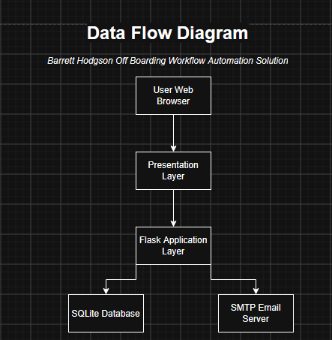

Figure 1 : Data flow diagram for the application

Functional Overview
The Off boarding Workflow Automation System manages employee clearance cases from initiation to final closure. It guides each case through the required departments, records checklist responses, sends task notifications, and provides authorised staff with visibility into current workflow status.

Case Creation
An authorized NOC user creates an offboarding case by entering the employee’s details. The system validates the details, generates a unique case number, and initiates the workflow. The case creation action is also recorded in the audit history.

Departmental Clearance Workflow
Each case follows a predefined workflow currently consisting of NOC Access & Security Clearance, MIS Business and Application Clearance, Hardware and Asset Recovery, and Final Admin Approval. Only the current task is made available, with the next department being assigned its task after the previous one has been completed.

Checklist Completion
Each department only completes the checklist configured for its workflow. Each item on the checklist consists of three possible responses: “YES”, “No”, and “Not Applicable”, along with a drop down consisting of that department’s employees. For each checklist item, the user must select one of the three possible responses, along with selecting the name of the employee responsible for that response from the aforementioned employee name drop down. In case “No”, or “Not Applicable” is selected, the user must provide a valid reason.

Email Notification and Secure Access
When a department task becomes active, the system sends an email containing the case reference, due date, and a secure task link. The recipient must use the secure task link to access the checklist. Notification attempts and delivery results are recorded by the system.

Case Monitoring and Printing
Authorized users (currently employees of the NOC department) can view the case register and open individual case records. The system displays the current workflow phase, completed tasks, checklist responses, and audit history. This allows pending or delayed clearances to be identified without the need of contacting each department individually. Authorized users can also print the relevant details of cases as well.

Overdue Task Handling
Each task is automatically assigned a due date based on the configured completion period. The system identifies active tasks that have passed their due date. Authorized users can then follow up with the concerned department and reissue a secure task link.

Final Approval and Case Closure
After all department’s tasks have been completed, the case enters the Final Admin Approval Phase. The approver can examine all the department’s checklist responses, as well as basic employee, and offboarding case information. After thoroughly reviewing each response, the admin can approve the case. Approval closes the case and records the final decision and completion time.

Basic End-to-End Workflow

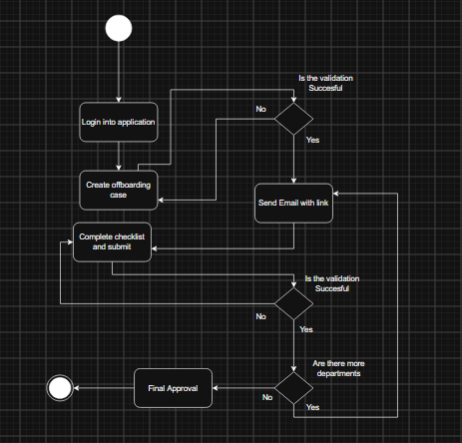

Figure 2: Activity diagram showcasing the basic flow of the application. Note: The activity diagram shows a highly abstracted version of the workflow

User Roles and Access

The system has three operational users: NOC, departmental users, and final approver. The NOC acts as the primary administrator of the off boarding process.

NOC User
The NOC user signs into the staff portal and manages the off boarding workflow, NOC user can create cases, view the case register, monitor progress, review notification results, print cases, and reissue departmental task links when necessary.

Departmental User
The departmental user can access their assigned checklist via a secure link generated by the system. They should not be given the login credentials to access the staff portal and should only be restrained to accessing their own departmental checklist.

Final Approver
The final approver reviews the completed checklists of each department and approves the case for closure.

User Interface and Operational Walkthrough
This section aims to present the main screens of the off boarding workflow automation system in the order in which they are normally used:

Staff Portal Sign-in
NOC users access the system through the staff sign-in page. The user enters their registered email address and password before being redirected to the dashboard. Invalid credentials prevent access to protected pages.

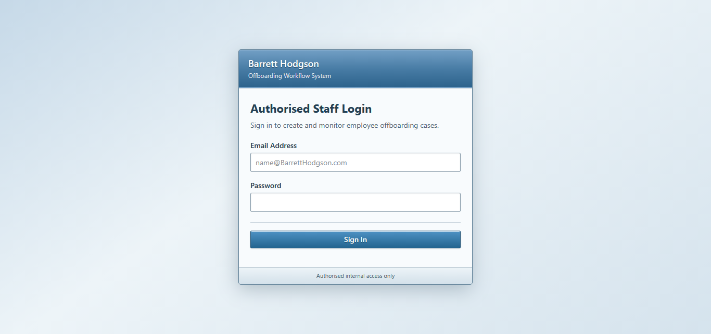
Figure 3: Staff Portal sign-in page

Dashboard
The dashboard allows the NOC user to view existing off boarding cases from one screen. It displays the case reference, employee information, current workflow stage, case status, and available actions. NOC users use this page to locate cases, view their information, and print them as well. The user also has the capability of searching, or filtering out the cases to only view the relevant ones.
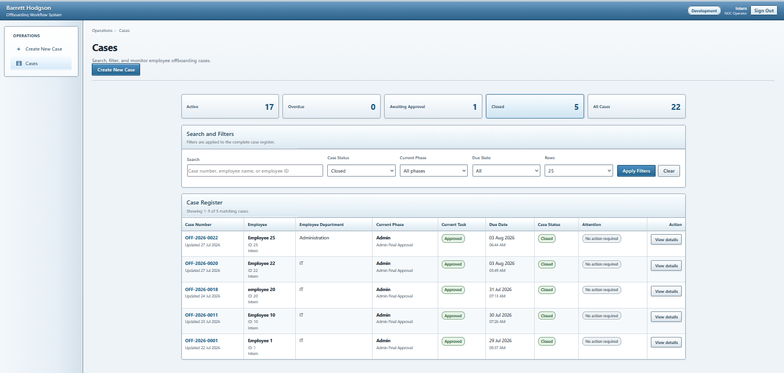
Figure 4: Case Dashboard accessible via Sign-in portal

Create Off boarding Case
NOC starts a new offboarding case by navigating to the “Create New Case” option located in the navigation bar. This option redirects them to a new off boarding case form, where the user must insert employee details, like employee name, department, last day of work, line manager, designation, and ID. Required fields are validated before the case is created. After which the workflow officially begins, and the user is redirected to a success page which confirms that the case has been successfully created along with relevant information about the off boarded employee.

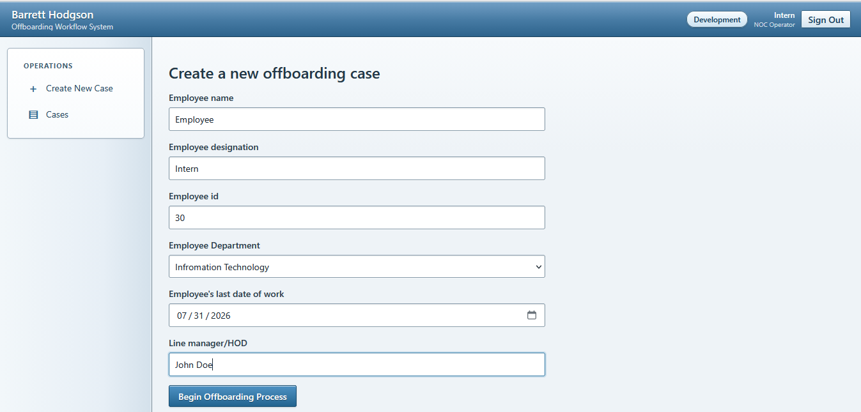
Figure 5: Off boarding case creation form
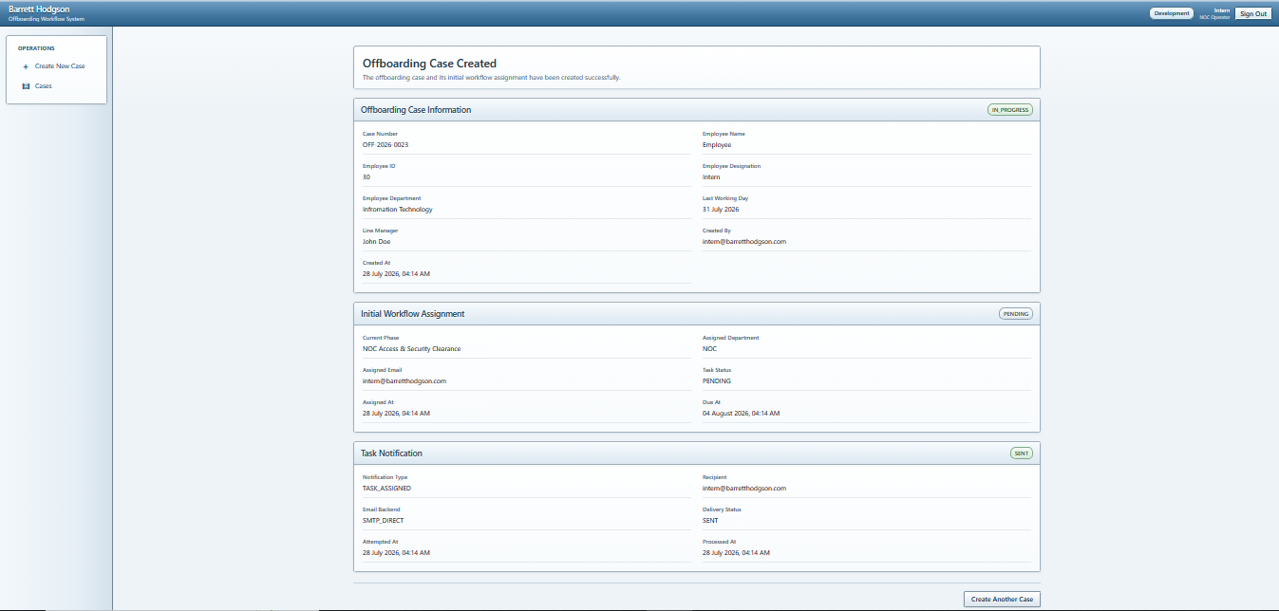
Figure 6: Case creation confirmation

Departmental Task access
When a departmental task becomes active, the assigned department receives an email with a secure task link. Opening the link takes the user directly to the departmental access page, without the need of signing into the application. The link is restricted to the assigned case and workflow.
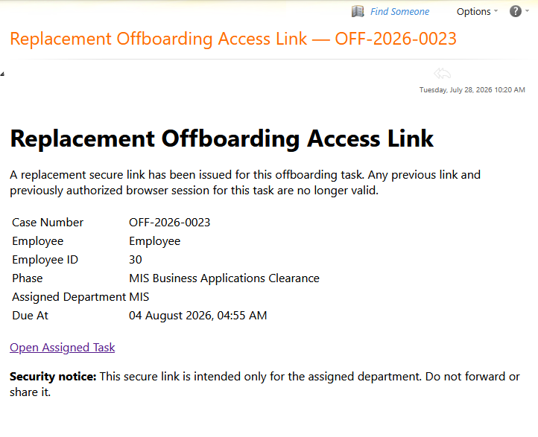
Figure 7: Figure 7: The assigned department receives the secure task link via Microsoft Outlook Web App. Note: Sensitive information has been redacted from this screenshot.
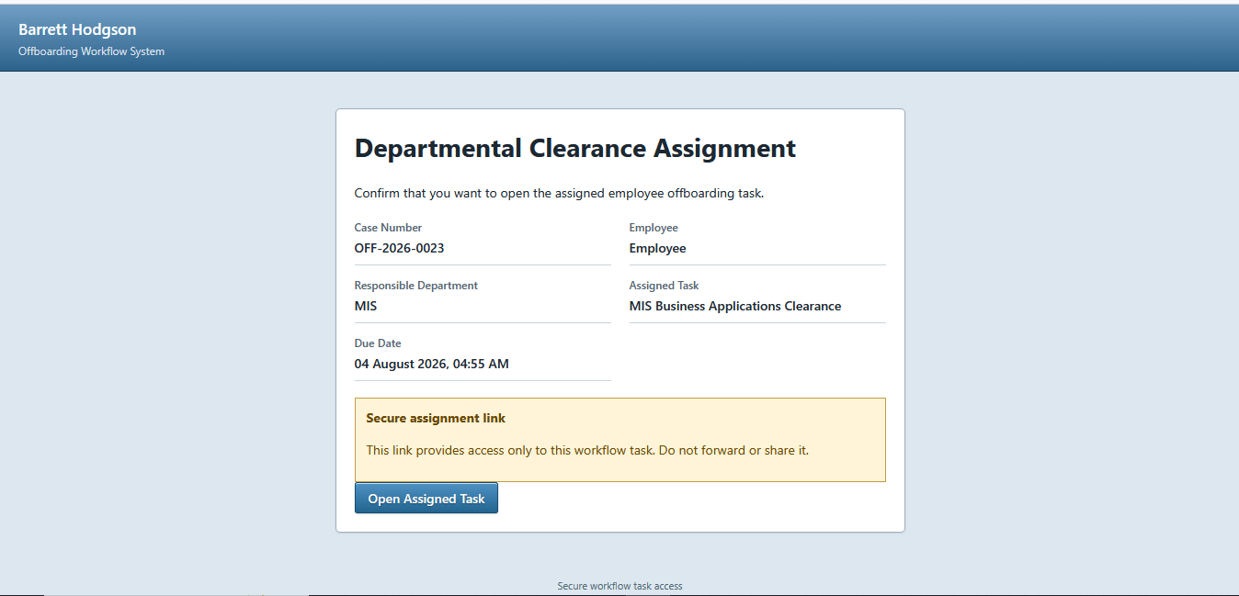
Figure 8: Departmental task access confirmation

Departmental Clearance Checklist
The departmental checklist displays the clearance items configured for the current workflow phase. For each item, the user selects a response along with the responsible employee. A reason must be given in case the user selects “No”, or “Not Applicable”.
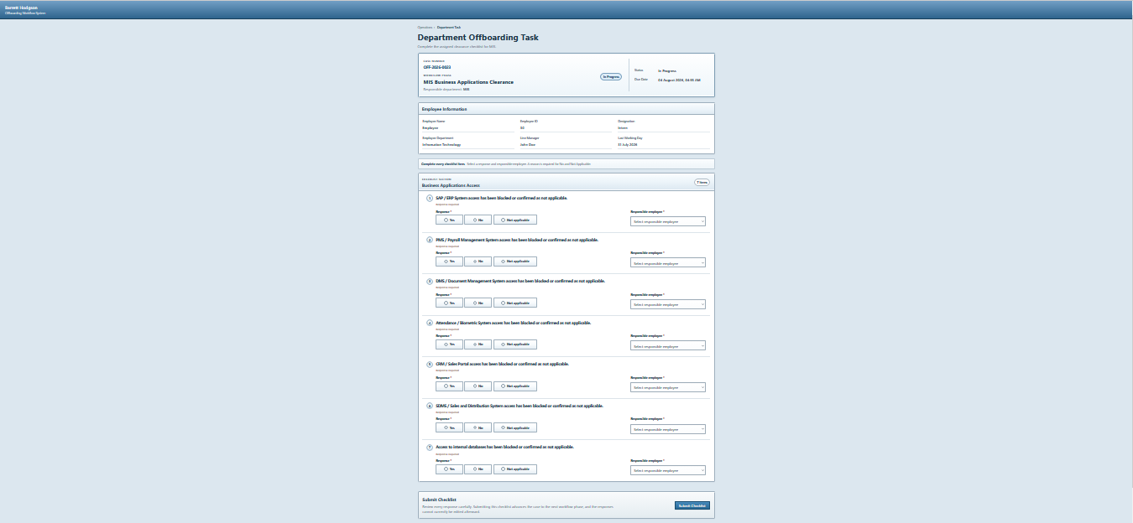
Figure 9: Departmental checklist for phase "MIS Business Applications Clearance". Note: The page has been zoomed out.

Case Details, Progress Monitoring, Printing, and Reissuing Links
The case details page allows NOC user to review the current state of an offboarding case. It shows the employee information, workflow progress, completed departmental checklists, notification records, and audit activity. This page is also used to print relevant details of the selected case. In case a departmental secure link is inaccessible, the NOC user also has the capability to issue a new link.
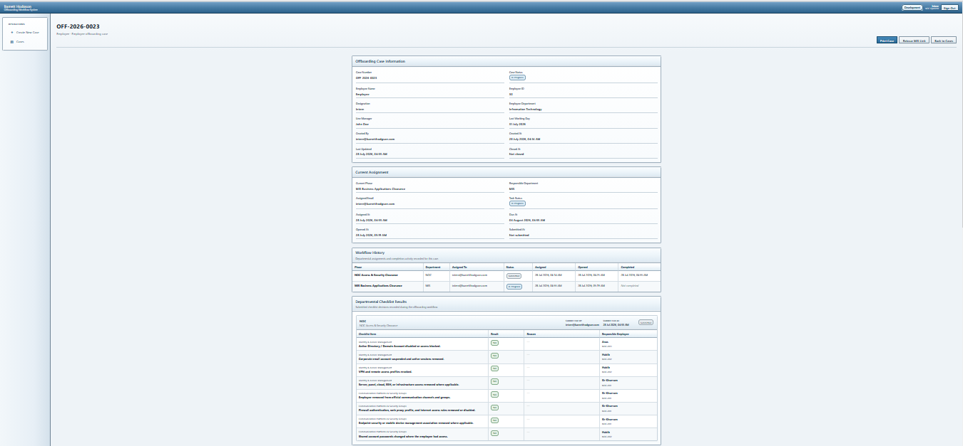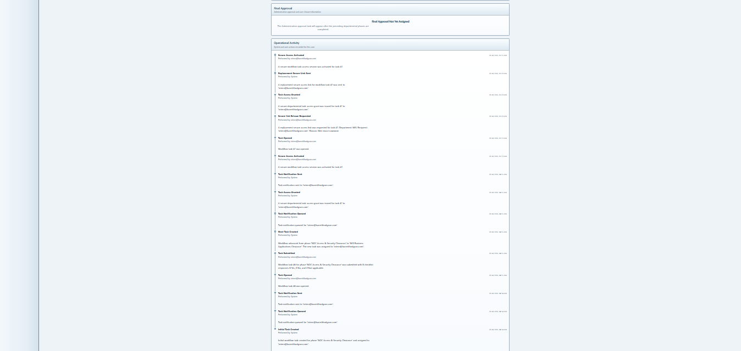
Figure 10: Complete details of a case, along with buttons to print case details, and reissue link.
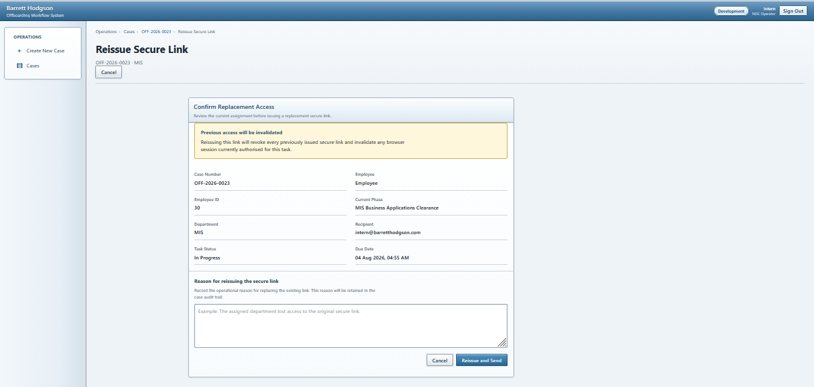
Figure 11: NOC user can reissue a task link in case the previous link becomes inaccessible. The NOC user must use this feature with caution.

Final HOD Approval
After all departmental checklists have been submitted, the case becomes available for final review. The approver can inspect the case information, each departments responses, and approve the case. They also have the capability of leaving an optional remark.
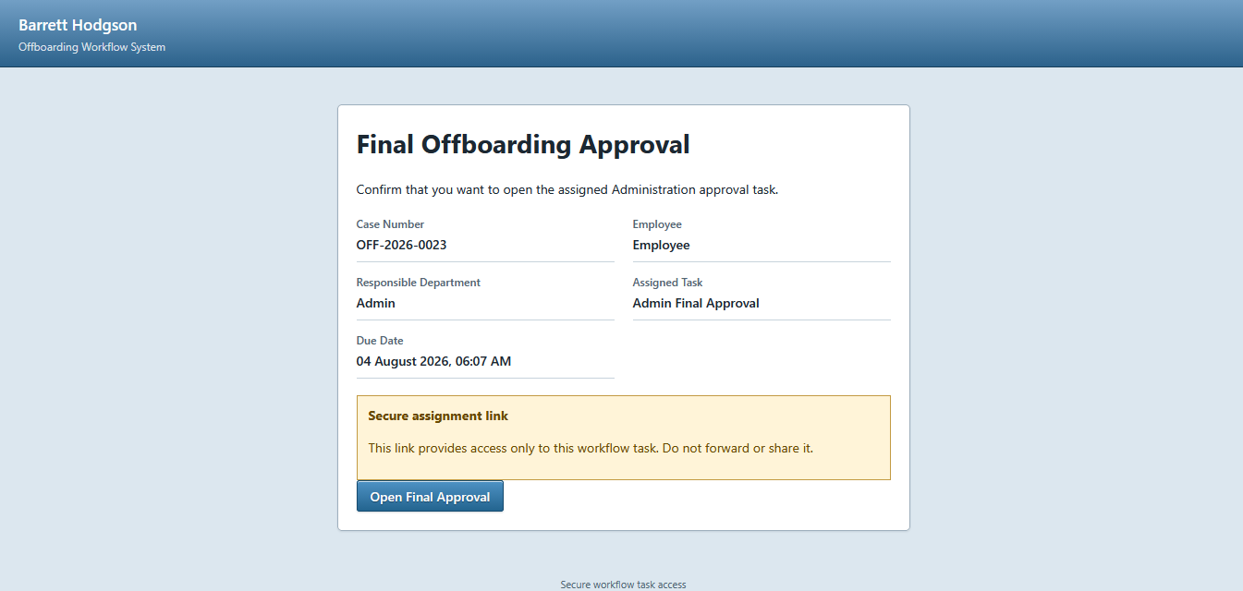
Figure 12: Final off boarding form access confirmation

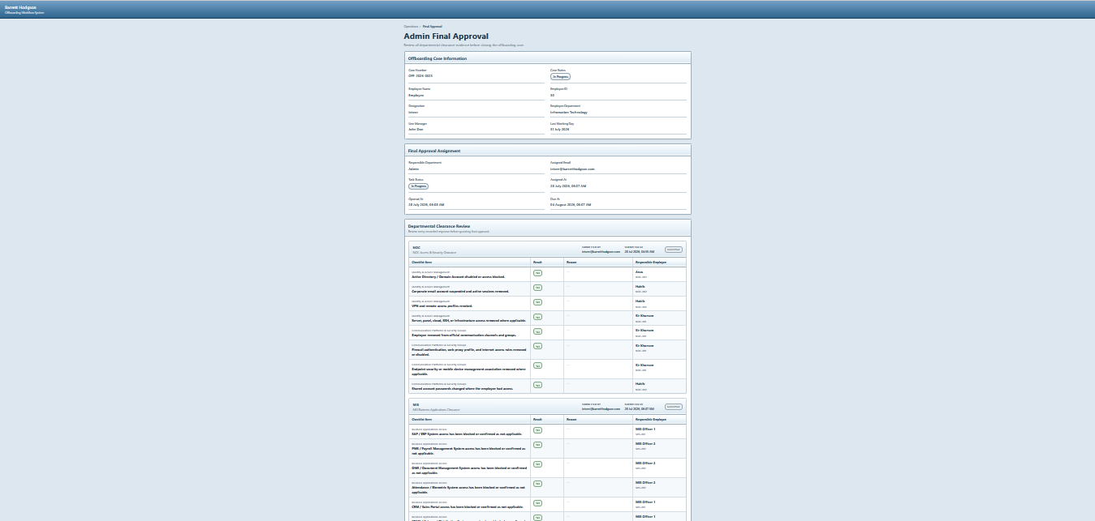
Figure 13: Final approval confirmation form

Workflow Processing Mechanism

Case Initialization
- NOC submits the new offboarding case form.
- Flask-WTF validates the submitted fields and CSRF token.
- The selected employee department is verified against the active department records.
- A new OffboardingCase record is created.
- The workflow phases are retrieved in their configured sequence.
- The first WorkflowTask is activated and assigned a due date.
- A secure task-access link and notification record are created.
- The case initialization is recorded in the audit history.

Departmental Checklist Submission
- The departmental user opens the secure task link received by email.
- The system validates the access token, expiry time, and task status.
- The checklist configured for the current workflow phase is displayed.
- Each response and responsible departmental employee is validated.
- A reason is required when Not Applicable, or No is selected.
- Valid responses are stored as ChecklistResponse records.
- The current task is marked as completed.
- The workflow progression process is then started.

Workflow Progression
- Workflow tasks follow the sequence defined by the configured phases.
- Only the current departmental task is available for completion.
- Completion of the current task activates the next workflow phase.
- A new secure link is generated for the next department.
- The next assignment notification is created and sent.
- After the last departmental task, the case moves to final approval.

Note: Workflow phases, checklist items, departments, and departmental employees must be configured before cases are processed.

Final Admin Approval & Closure
- The final approver opens the completed case through the staff portal.
- The system confirms that all required departmental tasks are complete.
- The approver reviews the submitted checklist responses.
- An approval decision is recorded.
- Approval changes the case status to closed.
- The decision and completion time are recorded in the audit history.
- A rejected case remains available for further action according to the implemented workflow.

Secure Task Link Mechanism

Link Generation
- A secure random token is generated when a departmental task becomes active.
- The raw token is included in the task URL sent to the department.
- Only a SHA-256 digest of the token is stored in the database.
- The access grant is linked to a specific workflow task.
- An expiry time is assigned according to the configured token lifetime.

Link Validation
When the task URL is opened, the system:
- Extracts the token from the request
- Calculates its SHA-256 digest
- Searches for the corresponding TaskAccessGrant in the database (Refer to the schema section for seeing the corresponding table).
- Verifies that the grant has not expired.
- Checks that it has not been revoked.
- Confirms that the associated task is still available.
- allows access only when all checks succeed
- Invalid, expired, or revoked links are rejected and do not expose the departmental checklist.

Link Reissue
NOC may reissue a task link when the original link is lost, expired, or considered compromised. The following steps occur in such case:
- Existing active grants for the task are revoked.
- A new token and access grant are generated.
- A replacement notification is sent to the configured department address.
- The reissue action is recorded for audit purposes.

Security Note: Secure task URLs must not be exposed in screenshots, logs, or in any other place. The usable token is sent only through the departmental email, while the database only stores its hash.

Email Notification Mechanism

How notifications are sent
- A notification record is created when a workflow task becomes active.
- The application prepares the relevant content for email.
- A secure task link is included where departmental action is required.
- Delivery is attempted through the configured SMTP backend.
- The notification status is updated after the attempt.
- Delivery errors are stored for troubleshooting.
- Console mode may be used during local development instead of sending an external email.

Notification Types

Notification | Purpose
Task assignment | Informs a department that its checklist is ready.
Replacement-link notification | Sends a newly issued secure task link.
Overdue escalation | Informs NOC that a task has passed its due date
Final-Approval Notification | Informs NOC that a task has passed its due date

Departmental Email Contents
A departmental assignment email normally includes:
- Case reference.
- Assigned department or workflow phase.
- Employee Information
- Due date
- Secure task link.
- Brief completion instructions.

Notification Tracking

Notification Status | Meaning
Pending | Notification has been created but delivery is not yet confirmed
Sent | SMTP delivery completed successfully
Failed | Delivery was unsuccessful and an error was recorded

Security Implementation

Implemented Security Controls

Security Control | Implementation
Staff authentication | Flask-Login with email and password authentication
Password protection | Passwords stored as secure hashes rather than plaintext.
Role-based authorization | Protected portal routes restricted by operational role
Departmental access | Task-specific secure URLs instead of general portal access
Token protection | Only SHA-256 hashes are stored in database
Token expiry | Configurable expiry time for task-access links
Token revocation | Existing grants can be invalidated during link reissue or task submission.
CSRF protection | Flask-WTF CSRF validation on state-changing forms
Session Protection | Session cookies are marked HttpOnly to prevent JavaScript from accessing session cookies, and SameSite=Lax to limit cross-site transmission.

